**ASSIGNMENT 01 FRONT SHEET**

|  |  |  |  |
| --- | --- | --- | --- |
| **Qualification** | **BTEC Level 5 HND Diploma in Computing** | | |
| **Unit number and title** | Unit 09: Software Development Life Cycle | | |
| **Submission date** | **24/September/2022** | **Date Received 1st submission** |  |
| **Re-submission Date** |  | **Date Received 2nd submission** |  |
| **Student Name** |  | **Student ID** |  |
| **Class** | GCH1005 | **Assessor name** | Michael Omar |
| **Student declaration**  I certify that the assignment submission is entirely my own work and I fully understand the consequences of plagiarism. I understand that making a false declaration is a form of malpractice. | | | |
|  |  | **Student’s signature** |  |

**Grading grid**

|  |  |  |  |  |  |  |  |
| --- | --- | --- | --- | --- | --- | --- | --- |
| P1 | P2 | P3 | P4 | M1 | M2 | D1 | D2 |
|  |  |  |  |  |  |  |  |

|  |  |  |
| --- | --- | --- |
| **❒ Summative Feedback: ❒ Resubmission Feedback:** | | |
| **Grade:** | **Assessor Signature:** | **Date:** |
| **Internal Verifier’s Comments:** | | |
| **Signature & Date:** | | |

List of figures 2

List of tables 2

Introduction 2

P1 Describe two iterative and two sequential software lifecycle models. 2

Iterative model: 2

Sequential model 2

A. Describe the following SDLC models: 2

Waterfall: 2

V-model: 3

Prototyping: 3

Scrum: 3

Spiral: 3

B. Choose the best model that you think is suitable for the project and explain why. 3

C. Discuss the suitability of each of the SDLC models for the project. For each model, specify whether it is most, moderately or least suitable 4

D. Discuss the suitability of each model. 4

E. Discuss the merits (Advantages) of applying the waterfall model to a large software development project. 5

P2 Explain how risk is managed in the Spiral lifecycle model. 5

A. Managing risk in Spiral life cycle model: 5

B. Identify some risks from the Tune source project and discuss an approach to manage them. 5

C. Provide a Risk Management process with clear illustrations and explanations. 5

D. Create a Risk Management Matrix to assess and manage risks of Tune Source project 5

P3 Explain the purpose of a feasibility report. 5

P4 Describe how technical solutions can be compared. 5

M1 Describe, with an example, why a particular lifecycle model is selected for a development environment. 6

M2 Discuss the components of a feasibility report. 6

Conclusion 6

References 6

# List of figures

Figure 1: Watrfall model 3

# List of tables

Table 1: Suitable model for TN Source 3

Table 2: Appropriate development model 4

Table 3: The suitability of each model 4

Table 4. Identified risks in TN source project 5

# Introduction

XXXXXXXX

# P1 Describe two iterative and two sequential software lifecycle models.

## Iterative model:

1. XXXX
2. XXXXX

## Sequential model

1. XXXXX
2. XXXXX

## Describe the following SDLC models:

### Waterfall:

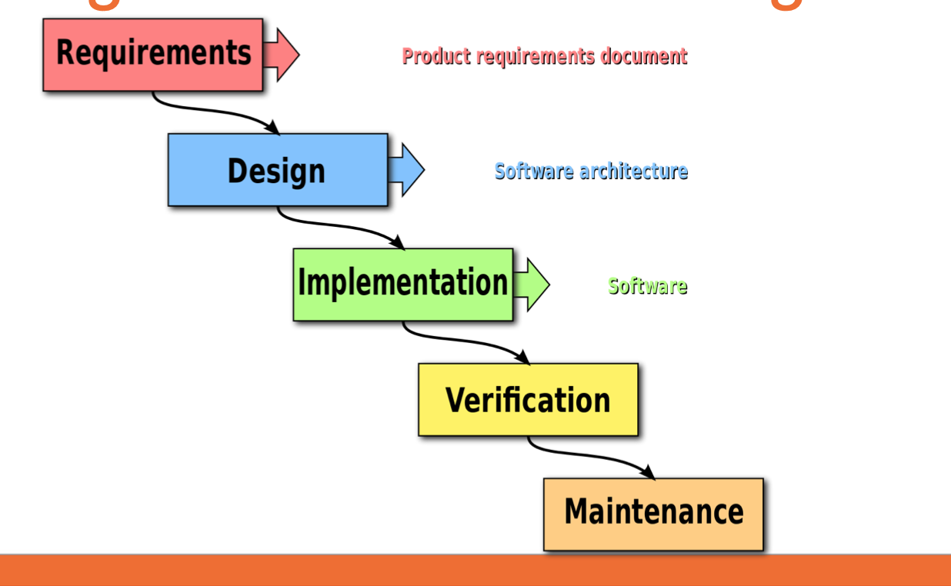

Figure 1: Waterfall model

### V-model:

### Prototyping:

### Scrum:

### Spiral:

## Choose the best model that you think is suitable for the project and explain why.

Table 1: Suitable model for TN Source

|  |  |
| --- | --- |
| **Choosing the Best model** | **Why is suitable** |
| Waterfall |  |

**Selecting appropriate development methodology.**

Table 2: Appropriate development model

|  |  |  |  |  |  |
| --- | --- | --- | --- | --- | --- |
| **Usefulness in developing TS. systems** | **Waterfall** | **V-model** | **Prototyping** | **Scrum** | **Spiral** |
| Clarity of User Requirements |  |  |  |  |  |
| Familiarity with Technology |  |  |  |  |  |
| System Complexity |  |  |  |  |  |
| System Reliability |  |  |  |  |  |
| Short Time Schedules |  |  |  |  |  |
| Schedule Visibility |  |  |  |  |  |

**Key:**

1. **Excellent**
2. **Good**
3. **Poor**

## Discuss the suitability of each of the SDLC models for the project. For each model, specify whether it is most, moderately or least suitable

Table 3: The suitability of each model

|  |  |  |  |
| --- | --- | --- | --- |
| **Models** | **Most** | **Moderately** | **Least suitable** |
| Waterfall |  |  |  |
| V-Model |  |  |  |
| Prototyping |  |  |  |
| Scrum |  |  |  |
| Spiral |  |  |  |

## Discuss the suitability of each model.

1. Waterfall model
2. V-Model
3. Prototyping model
4. Scrum model
5. Spiral model

## Discuss the merits (Advantages) of applying the waterfall model to a large software development project.

Xxxxxxxx

# P2 Explain how risk is managed in the Spiral lifecycle model.

## Managing risk in Spiral life cycle model:

Xxxxxxxxxxxxx

## Identify some risks from the Tune source project and discuss an approach to manage them.

Table 4. Identified risks in TN source project

|  |  |
| --- | --- |
| **SN** | **Risk in Tune source projects** |
| 1 |  |
| 2 |  |
| 3 |  |
| 4 |  |

## Provide a Risk Management process with clear illustrations and explanations.

## Create a Risk Management Matrix to assess and manage risks of Tune Source project

# P3 Explain the purpose of a feasibility report.

# P4 Describe how technical solutions can be compared.

|  |  |  |  |  |  |  |
| --- | --- | --- | --- | --- | --- | --- |
| **Criteria** | **Alternatives** | | | | | |
|  | **Weight** | **PHP** | **JAVA** | **C#** |  |
| * Cost |  |  |  |  |  |
| * Response time |  |  |  |  |  |
| * Training time |  |  |  |  |  |
| * Ease of use |  |  |  |  |  |
| * Team Experience |  |  |  |  |  |
|  | **Total** |  |  |  |  |  |
| **Weighted total** |  |  |  |  |  |

# M1 Describe, with an example, why a particular lifecycle model is selected for a development environment.

# M2 Discuss the components of a feasibility report.

# Conclusion

# References